# Mini database level 4

## 

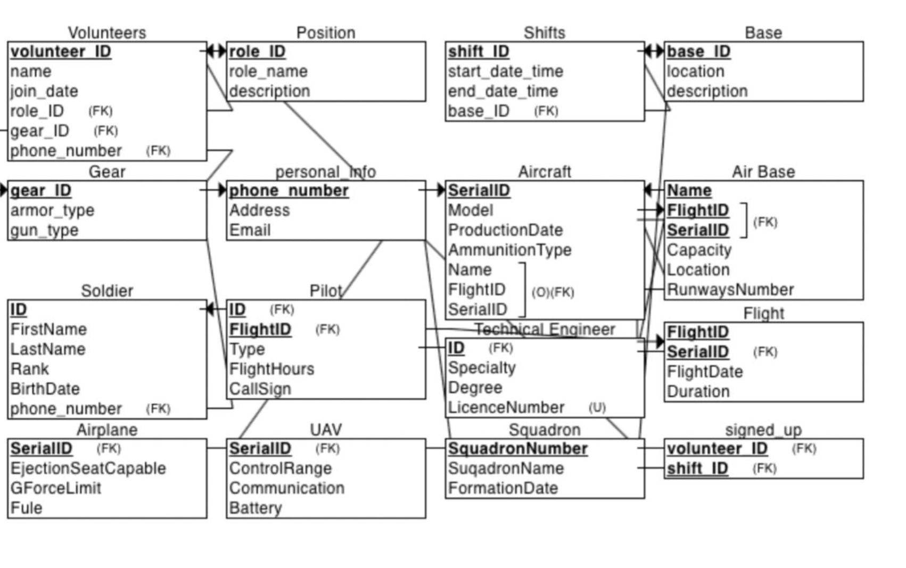

# 

Combined

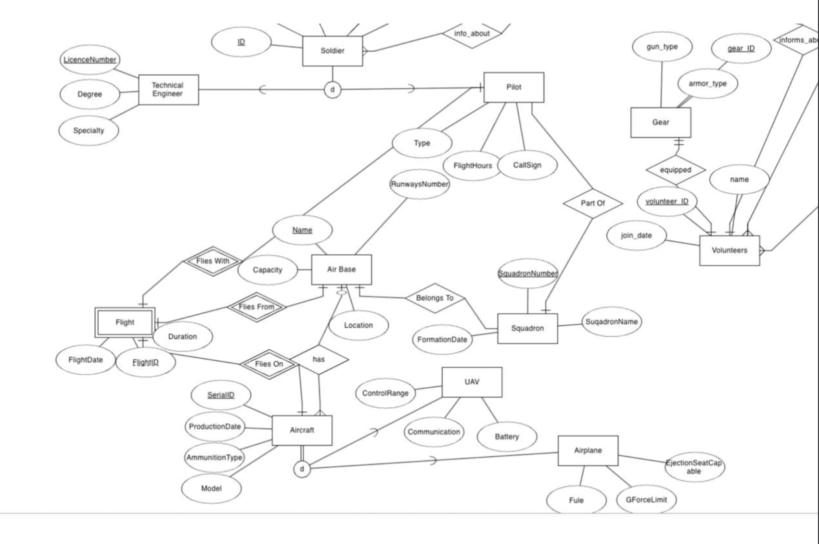

# 

# SQL Views and Queries Report

Integration:

We wanted to add the connection between personal info and soldier because we believe it adds much benefit to the data-base, we chose the connection to be many too one because 2 soldiers or more

# Different view for every wing:

# 1. SOLDIER_VIEW

This view selects all soldiers' basic information from the SOLDIER table.

## View Definition:

CREATE OR REPLACE VIEW SOLDIER_VIEW AS  
SELECT id, first_name, last_name, rank, birthdate, phone_number  
FROM SOLDIER;

## Example Queries:

#### Query 1:

Retrieve all soldiers with the rank 'Turai':

SELECT id, first_name, last_name, rank, birthdate, phone_number  
FROM SOLDIER_VIEW  
WHERE rank = 'Turai';  
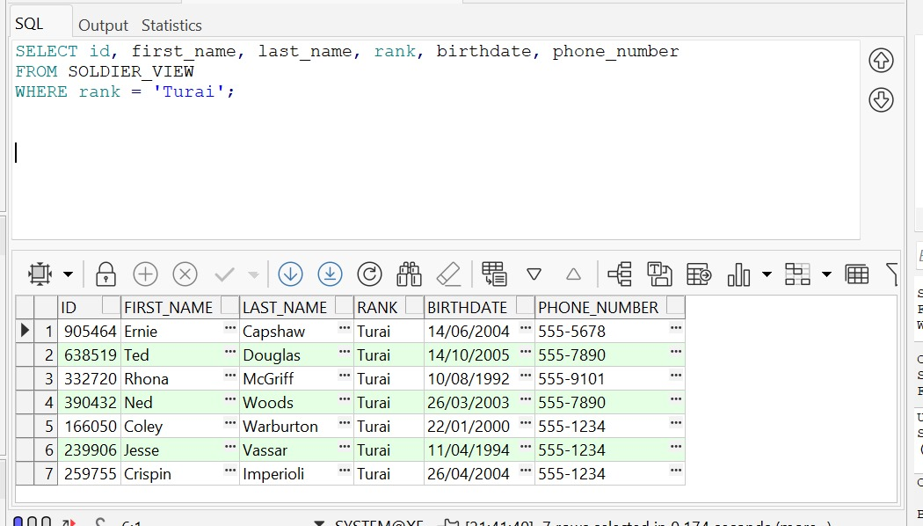

## Query 2:

Retrieve all soldiers born before January 1, 1990:

SELECT id, first_name, last_name, birthdate, phone_number  
FROM SOLDIER_VIEW  
WHERE birthdate < TO_DATE('1990-01-01', 'YYYY-MM-DD');  
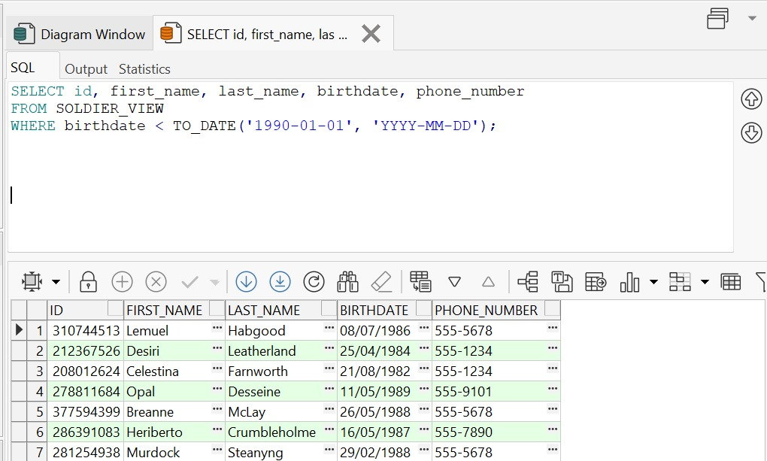

# 2. PERSONAL_INFO_VIEW

This view selects contact information from the PERSONAL_INFO table.

## View Definition:

CREATE OR REPLACE VIEW PERSONAL_INFO_VIEW AS  
SELECT phone_number, address, email  
FROM PERSONAL_INFO;  
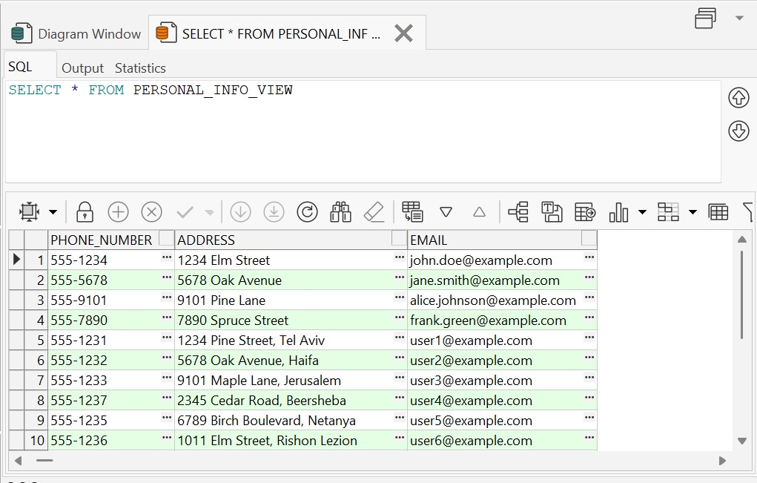

## Example Queries:

#### Query 1:

Retrieve contact details for a specific phone number:

SELECT phone_number, address, email  
FROM PERSONAL_INFO_VIEW  
WHERE phone_number = '555-1234';  
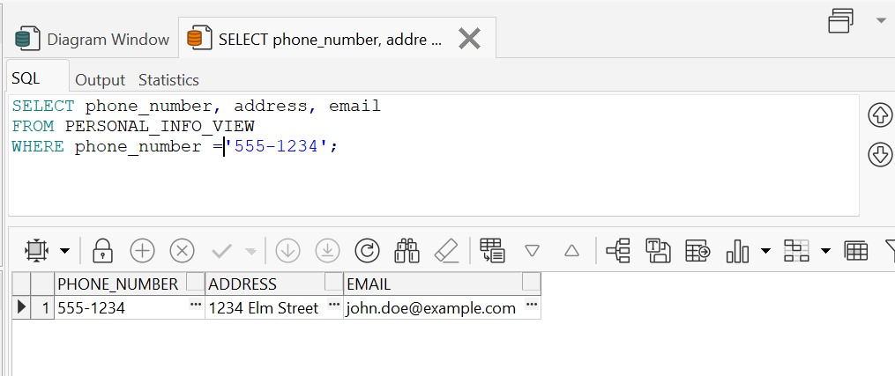

## Query 2:

Retrieve contact details for addresses containing 'תל אביב':

SELECT phone_number, address, email  
FROM PERSONAL_INFO_VIEW  
WHERE address LIKE '%1234 Elm Street%';  
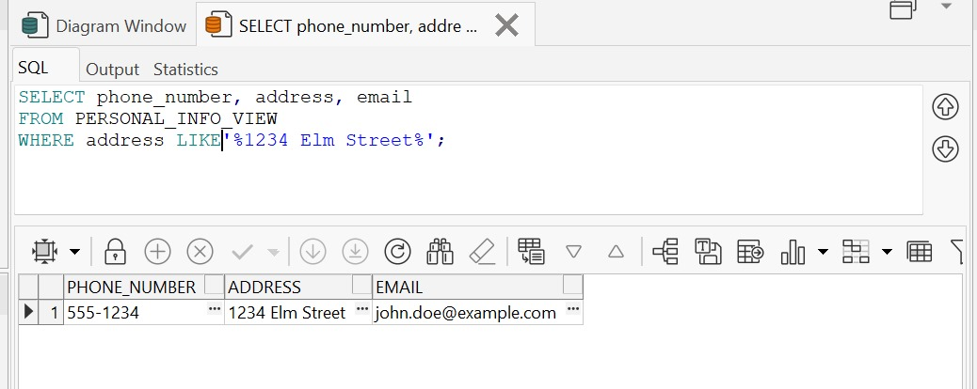  
**Mixed views:**

# 3. SOLDIER_PERSONAL_INFO

This view joins the SOLDIER and PERSONAL_INFO tables on phone_number to combine soldier information with their personal contact details.

## View Definition:

CREATE OR REPLACE VIEW SOLDIER_PERSONAL_INFO AS  
SELECT s.id, s.first_name, s.last_name, s.rank, s.birthdate, p.address, p.phone_number, p.email  
FROM SOLDIER s  
LEFT JOIN PERSONAL_INFO p ON s.phone_number = p.phone_number;  
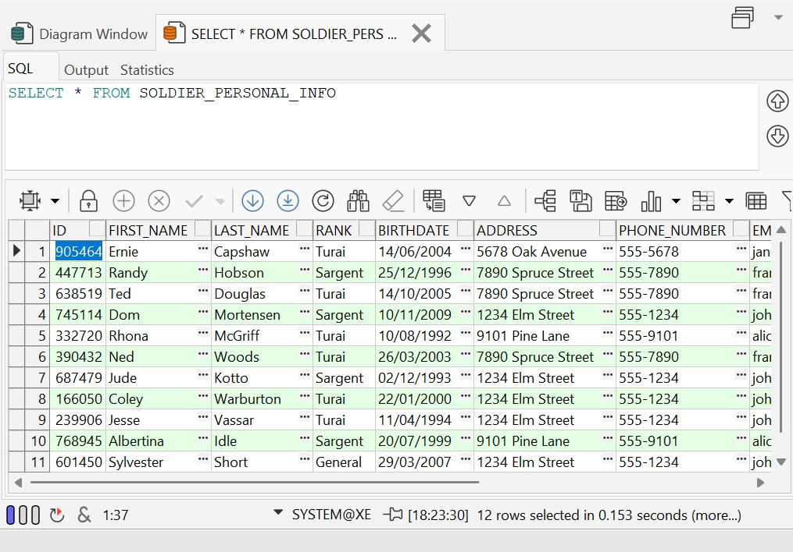

## Example Queries:

#### Query 1:

Retrieve all 'Turai' soldiers with their personal information:

SELECT id, first_name, last_name, rank, birthdate, address, phone_number, email  
FROM SOLDIER_PERSONAL_INFO  
WHERE rank = 'Turai';  
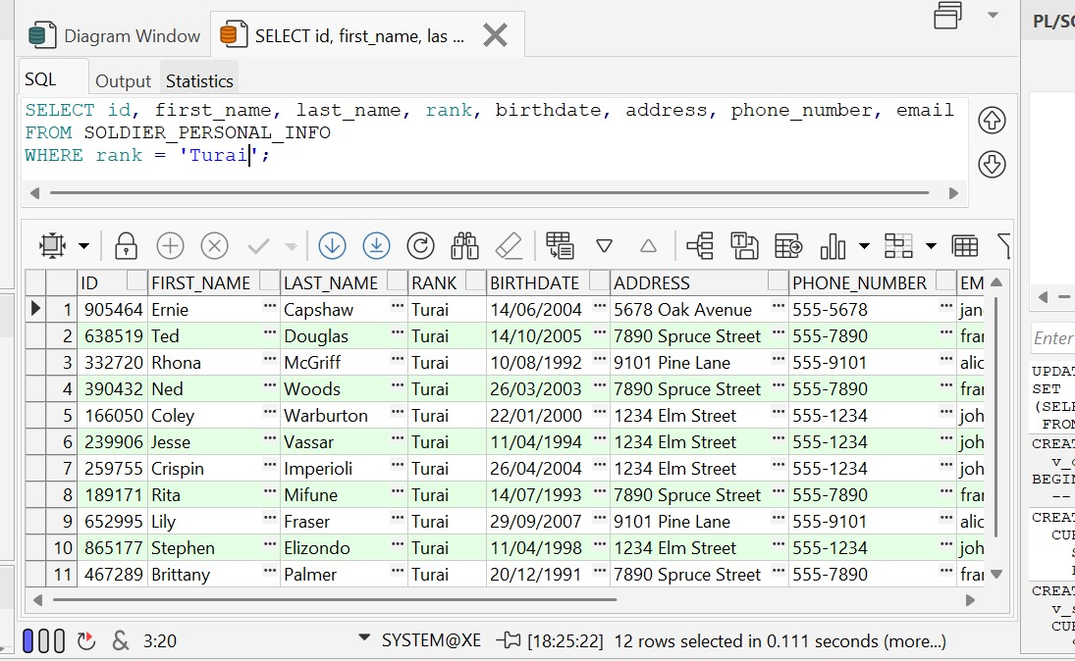

## Query 2:

Retrieve soldiers born after January 1, 1999, with their personal information:

SELECT id, first_name, last_name, birthdate, address, phone_number, email  
FROM SOLDIER_PERSONAL_INFO  
WHERE birthdate > TO_DATE('1999-01-01', 'YYYY-MM-DD');  
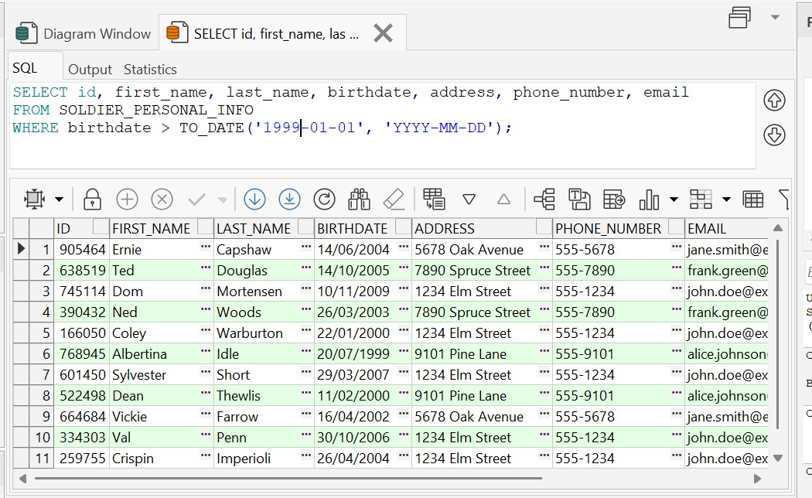

# 4. PERSONAL_INFO_SOLDIER

This view joins the PERSONAL_INFO and SOLDIER tables on phone_number to combine personal contact details with soldier information.

## View Definition:

CREATE OR REPLACE VIEW PERSONAL_INFO_SOLDIER AS  
SELECT p.phone_number, p.address, p.email, s.id, s.first_name, s.last_name, s.rank, s.birthdate  
FROM PERSONAL_INFO p  
LEFT JOIN SOLDIER s ON p.phone_number = s.phone_number;  
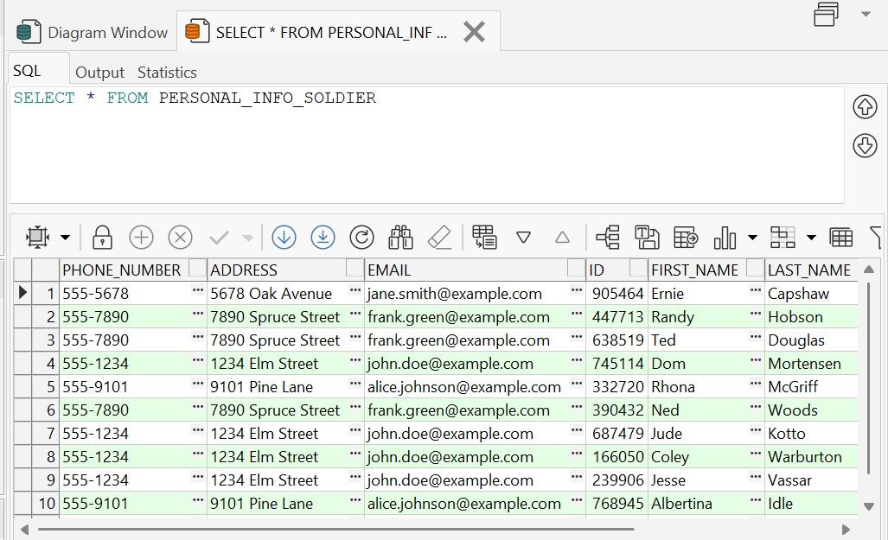

## Example Queries:

#### Query 1:

Retrieve soldier information for a specific phone number:

SELECT phone_number, address, email, id, first_name, last_name, rank, birthdate  
FROM PERSONAL_INFO_SOLDIER  
WHERE phone_number = '555-7890';  
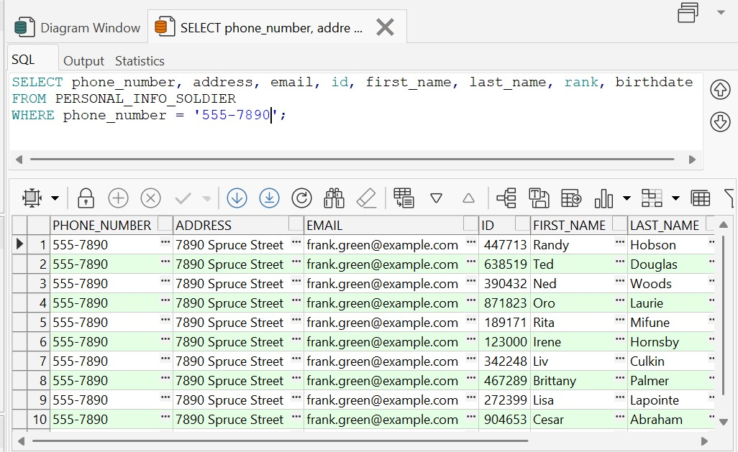

#### Query 2:

Retrieve soldiers living at a specific address:

SELECT phone_number, address, email, id, first_name, last_name, rank, birthdate  
FROM PERSONAL_INFO_SOLDIER  
WHERE address LIKE '%7890 Spruce Street%';  
